}

Guía1. Definición Proyecto APT
Asignatura Capstone

- PARTE I
1. Antecedentes Personales
A continuación, se presenta una tabla en la que debes completar la información solicitada.

Nombre estudiante | Alexander Hernández  Álvaro Muñoz  Abel Sánchez
Rut | 21.277.965-2  21.508.094-3  21.342.568-4
Carrera | Ingeniería en Informática
Sede | Plaza Norte

2. Descripción Proyecto APT
En la descripción debes señalar brevemente el nombre de tu proyecto APT y las competencias del perfil de egreso que vas a poner en práctica. Si en tu carrera están definidas las áreas de desempeño, también menciona a qué áreas de desempeño está vinculado el proyecto.

Nombre del proyecto | College Choice helper
Área (s) de desempeño(s) | Fictional scenario
Competencias | IT Project management  Software development  Database modeling  Database queries  Software architecture modeling  Quality testing | Quality assurance  Fix system’s vulnerabilities

3. Fundamentación Proyecto APT
A continuación, se presentan distintos campos que debes completar con la información solicitada. Esta sección busca que describas en detalle tu proyecto y justifiques su relevancia y pertinencia.

Relevancia del proyecto APT | A common problem for high schoolers, more so on their last year, is not knowing what to study, and a problem derived from it is not knowing where to study, this is an issue that causes a lot of anxiety in the young ones and that we, the team itself, have suffered through.  The project we have in mind seeks to help students across Chile suffering from this issue.
Descripción del proyecto. | It’s a web site that, by using certain parameters, is able to offer recommendations for students about where to study the degree they’re interested in, using information like how close it is from their home, if free education is available on it, certifications, among others, while also presenting the results to the users in a visual and understandable way so that they can take an informed decision.  That would be about the functional aspect of the system, now on quality traits, we want to make a safe website, with well defined roles to avoid users having access to stuff they shouldn’t be able to interact with, ciphered passwords and logical authentication.  Also, quality tests will be done, such as load, stress and usability to ensure that the system works how it’s supposed to, since it’s key that the tool It’s comfortable to use by the users.  To finish, we want to add “disclaimers” to the website’s use, this is because after all there’s people who already know where they want to study or they have a “dreamed university”, and the purpose of our solution is not, in any case, discourage those persons or in general choose for the students, we simply want to offer a bit of guidance so that they can have some reference to use and take a good decision.  The project will be developed on Django, this is because this framework is effective, has built-in cybersecurity features, keeps receiving updates and as a team we’re well used to development with this tool.
Pertinencia del proyecto con el perfil de egreso | To carry out this project there’s several skills related to our graduation profile:  - IT Project management: The whole process of planning and management around our project.  - Software development: The project itself is going to be made by software development.  - Data base modeling: Graphically represent the data structure to develop the website correctly.  - Database queries: The system must have CRUD functionality to interact with the database.  - Software architecture modeling: The website will be built using Model View Controller pattern design.  - Quality Testing: The application of quality tests to put the system’s capabilities to the test.  - Fix system’s vulnerabilities: The search and subsequential fixing of errors and vulnerabilities that are present on the website.
Relación con los intereses profesionales | The professional interests of the team are aligned around software development, database management and data science, all areas that could and will be applied to the development of this project.
Factibilidad de desarrollo del Proyecto APT | The Project we have in mind is perfectly doable on the four months we have on the semester; there’s no need for a lot of resources since we intend to use open-source tools.  About certain situations that make development easier, we have the fact that it is a problem we ourselves have lived and thus are aware of it, which allows us to have some insight into the reality we are working with.  Now if we want to take a look at the possible liabilities we may have, it is possible the team has limited time due to the internship we must all do this semester, alongside the many processes we may have to indulge as senior year students, which may limit even more the time available, more so than we think.

- PARTE II
4. Objetivos
En este apartado debes definir objetivos generales y específicos del Proyecto APT. Es importante aclarar que los objetivos se deben plantear en forma clara, concisa y sin dar mayores explicaciones, es decir, deben entenderse por sí solos. Se sugiere redactarlos utilizando un verbo en infinitivo, pues ello obliga a precisar acciones concretas.

Objetivo general | The general objective is to produce a web site that middle schoolers would find useful.
Objetivos específicos | -Design a proper database.  -Develop an efficient and effective website.  -Reduce vulnerabilities to a minimum.  -Keep the development under the deadline.  -Document every process properly.

5. Metodología
En el siguiente apartado deberás describir la metodología, propia de tu disciplina, que utilizarás para resolver el proyecto APT antes descrito, incluyendo las etapas y métodos de trabajo.

Descripción de la Metodología
The most effective way to develop this project on our opinion is to use agile methodologies, ideally SCRUM, this is due to it working with multiple deliveries, adding functions progressively prioritizing the most important ones, which is why we think it’s the best option.
As a Scrum Project there is some roles to be considered:
Product owner: The one who is closest to the client and connects their needs with the team – Álvaro Muñoz.
Scrum Master: The one who organizes the work structure, defines objectives and makes sure they are met. – Abel Sánchez.
Team Scrum: The team who develops the project by doing the needed activities. – Alexander Hernpández.
Our application of these roles can be a bit different than the traditional way since it is a fictional scenario and we aren’t working with a real client, however we do need these roles in order to do a good job.

About the work plan, we are planning on dividing it into 4 phases:
-First sprint: Focused on planning and defining the baseline, some activities to do here will be a mockup, database modeling, architecture modeling, among others.
-Second sprint: Focused on the coding of the functionalities, especially the most essential ones like login, parameter weighting and graphic visualization to name a few.
-Third print: Focused on finishing any potential delayed activity, and additionally apply quality control, like load and stress tests, data encryption, and hosting.
-Fourth sprint: On the last sprint the focus will be the design (also known as the front-end) of the website, which means all that regards order, colors and overall aesthetic of the system on the user side.

6. Evidencias
A continuación, describe qué evidencias serán evaluadas en el informe de avance y en el informe final de tu proyecto APT. Estas evidencias deben ser acordadas con tu docente. Se entenderá por evidencia los productos que se desarrollen durante el proyecto y cuyo propósito sea visibilizar o documentar cómo se ha implementado el trabajo.

Tipo de evidencia  (avance o final) | Nombre de la evidencia | Descripción | Justificación
Advance | Schedule | Visual representation of the planning, done in a Gantt chart to show the work to be done during the 18 weeks. | A Good tool to show the structure our team will follow.
Advance | Agile report | Formal document that contains details about the project using agile methodology as a base, including requirements, the problem, justification, among others. | Defines the most important aspects in a specific way so that they can be verified later on with the final result.
Advance | Sprint planning | A series of documents before and during each sprint to define the activities to be done on them, tasks to do, delays, adjustments among other details. | Allows to keep track of the progress of every sprint, which probes that it was done like planned or if there were any impediments.

7. Plan de Trabajo
En la siguiente tabla define la planificación de tu Proyecto APT de acuerdo a lo requerido.

Plan de Trabajo Proyecto APT
Competencia o unidades de competencias | Nombre de Actividades/Tareas | Descripción Actividades/Tareas | Recursos | Duración de la actividad | Responsable | Observaciones
IT Project Management. | Do the articles of incorporation. | Write the articles of incorporation to formally start the project, as well as to define the scope, the requirements, among other aspects. | Microsoft word | 2 hours | Álvaro Muñoz
IT Project Management. | Do EDT | Elaborate an EDT chart to visually show the activities for each phase. | Microsoft Excel | 2 hours | Álvaro Muñoz
Database modeling | Do a model for the database | Elaborate the model for the database needed in our system. | Lucidchart | 6 hours | Abel Sánchez
Software development | Do a model for the website | Elaborate a simple mockup that helps explain the key elements of the website, as well as it's functioning. | Canva | 12 hours | Álvaro Muñoz
Software architecture modeling | Do a model for the architecture | Elaborate diagrams that helps explain visually the different components of the system. | Lucidchart | 6 hours | Abel Sánchez
IT Project Management. | Do the traceability matrix | Elaborate a document to keep track of the progress on each task. | Microsoft Word | 2 hours | Alexander Hernández
Software development | Create and configure the Django project | Start the Django Project and the initial configurations needed. | Python  Django | 2 hours | Alexander Hernández
Database modeling | Create the database | Agregar los modelos de datos equivalentes a tablas dentro del proyecto Django.  Create the database tables equivalent on Django data models | Python  Django | 4 hours | Abel Sánchez
Software development | Create templates and web pages. | Design the pages we will use | Python  Django | 8 hours | Alexander Hernández
Software development  Database queries | Code the functions | Code every function needed for the system to work. | Python  Django | 16 hours | Abel Sánchez
Software development | Connect to the database. | Properly connect the system with a database manager in order to storage the information. | Python  Django  PostgresSQL | 6 hours | Abel Sánchez
Fix system vulnerabilities | Implement cybersecurity | Add and/or verify the security on the system. | Python  Django | 6 hours | Alexander Hernández
Software development | Aesthetic enhancement | Develop an attractive design for the website. | Python  Django | 10 hours | Álvaro Muñoz
Software development | Hosting | Load the system on a hosting server so that any user can access it. | Hosting tool still not defined. | 4 hours | Alexander Hernández
Quality testing | Quality assurance | Vulnerability mapping | Use Owasp to find vulnerabilities on the system | Owasp Zap | 2 hours | Álvaro Muñoz
Quality testing | Quality assurance | Load and stress testing. | Apply tests in order to determine the ability to manage large amounts of users at the same time. | Jmeter | 2 hours | Álvaro Muñoz
IT Project Management. | White march | Offically publish the system for real users. | Broadcast media | 6 hours | Alexander Hernández
IT Project management. | Project closure | Elaborate the documento to formarly end the project. | Microsoft Word | 4 hours | Álvaro Muñoz

8. Carta Gantt
Busca un formato de Carta Gantt que te acomode y organiza en este las actividades planificadas en el punto anterior considerando el periodo asignado para el desarrollo de tu Proyecto APT. Debes mantener la temporalidad del periodo académico en el desarrollo de las tres fases que contempla la Asignatura de Portafolio de Título.

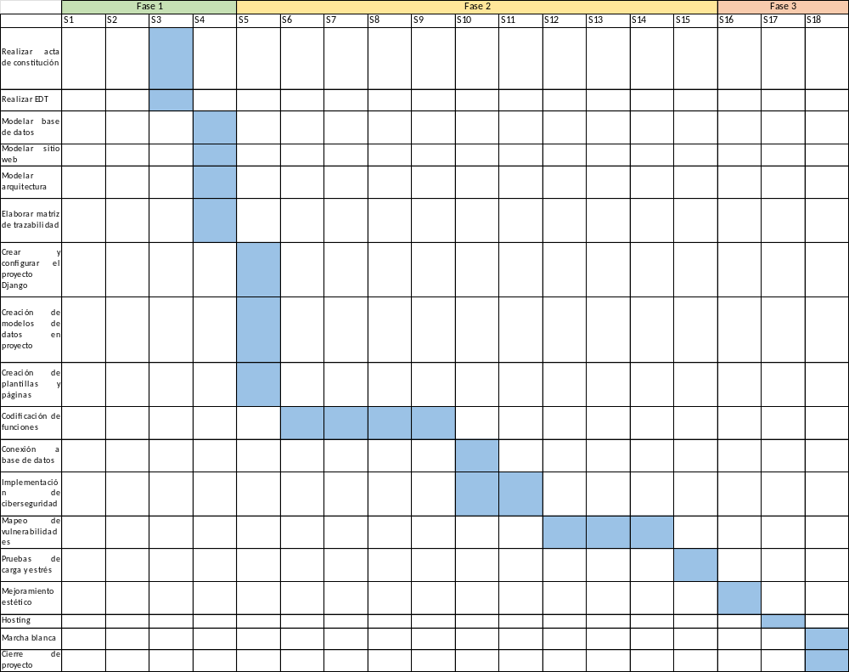

En caso de que el Proyecto APT sea grupal, en esta columna deben indicar el nombre de los responsables de cada tarea o actividad. Esto posteriormente permitirá diferenciar la evaluación por cada integrante.

